Shuzworld – Shanghai production facility

To: Cynthia Crowninshield

**From:** Aaron Camacho, Operations Consultant

**Subject:** Shuzworld’s Shanghai Production Facility Improvements

**Date:** January 16th 2014

**Workflow Improvements**

**Recommendation**

Shuzworld can improve its workflow by reducing amount of workstations in its Rugged Wear Work boot assembly line from eight to five. With eight stations the assembly line is currently running at 57.5 percent efficiency. This means that 42.5 percent of the time workers are idly standing around with no work to do. With five stations efficiency would increase to 92 percent. To achieve five stations, stations ‘B and C’ need to be combined together and stations ‘E, F and G’ together need to be combined together. All other stations stay the same. In this way we stay within the allotted 10-minute cycle period and decrease the amount of time that is idly wasted.

Also, the assembly line can be reconfigured into a U-shape. The U-shape makes units and workers in an assembly line be within close proximity. Having the units and workers closer together carries some unique advantages. A few advantages are (1) Workers can more easy help one another; (2) Communication efficiency is increased; (3) Workers can be cross-trained for multiple jobs within a line reducing boredom and job satisfaction and ultimately employee turnover; (4) reduces the amount an employ needs to move which is beneficial to health and to the amount of time that is wasted moving back and forth on straight assembly line; (5) Can reduce the amount of workers necessary; (6) Reduce the space required, and; (7) The product can be inspected easily throughout the whole production process.

**Tool Used to Make Decision**

The decision analysis tool used to analyze the rugged boot assembly line schedule was ‘assembly line balancing’ in Excel OM. It is important to note that multiple priority rules could be chosen within the ‘assembly line balancing’ analysis tool. Though changing the priority rule changes the efficiency outcome and assembly line structure in many scenarios the rugged wear work boot assembly line was unchanged when the priority rule was changed. The reason the ‘assembly line balancing’ tool was chosen was because the tool identifies how to optimize an assembly line. For example, the Shuzworld plant was not sure if the rugged wear work boot assembly line was running are its peak efficiency with eight stations. By quickly plugging in the information the ‘assembly line balancing’ tool was able to show the potential that could be accomplished if the assembly line was reconfigured to five stations.

**Maui Sandal Cost Structuring**

**Impact Costs**

The learning curve of an individual denotes how quickly some one can learn and/or approve upon certain tasks. For example, building a 2’ x 4’ wood cabinet for the first time may take you 10 hours. Ten hours is a bit long. However, lets say it has been determined from previous projects that you have a learning curve of about 80 percent. Having a learning curve of 80 percent theoretically means the second 2’ x 4’ wood cabinet should only take 8 hours for you to build (10*{2 ^ -0.3219281} = 8). The time to produce third, fourth, fifth and to up and past the thousandth cabinet can be calculated. Understanding learning curves and their ability to reduce the amount of labor hours necessary to complete a particular unit is huge when negotiating a pricing structure. A contractor may tell you that it will take 10 labor hours to complete the cabinet above, though, if you new that the third cabinet will only take 7.02 hours you may be able to negotiate a price based upon the third cabinet not the first. Such negotiation can greatly reduce the overall labor costs, especially when hundreds or thousands of cabinets will be made.

Similarly, the Maui sandal project has a learning curve of 80 percent. Though the first batch will take 1000 hours to complete the fifth batch will only take 595.6 hours to complete (1000*{5 ^ -0.3219281} = 595.6). With the learning curve in mind we can now perceive a likely budget to be more around the average of the first five batches instead of the 1000 hours expected on the first batch. Each, months batches can be similarly averaged to gain an assumed labor budget cost. The rule of thumb to learn here is, as more units are produced, the better and faster we get at making them. Therefore, the 50th unit will not cost nearly as much as the 1st.

Just like the labor cost of the five batches in the first month became less when the learning curve algorithm was applied, so does the second, third, fourth, and fifth month batches. However, it is important to note that with each increasing unit the learning curve decreases in potency. For example, the difference in the labor hours needed to complete batch one versus batch two of the Maui Sandal is 200 hours (1000hrs. first batch – 800hrs. second batch = 200hrs.). However, the difference in the labor hours needed to complete batch 49 versus batch 50 of the Maui Sandal is two hours (308.53hrs. 49th batch – 306.53hrs. 50th batch = 2hrs.).

**Tool Used to Make Decision**

“Learning Curves – determining times” was the decision analysis tool used to analyze the initial and on going costs needed for the new Maui sandal line. The “learning curves” decision analysis tool was chosen for its ability to quickly calculate how much faster someone or some group could produce an item after multiple attempts. The math in the learning curve tool denotes that with every unit the time used to make that unit should be less. The learning curve tool was able to quickly and accurately calculate the time needed to complete each batch of 10,000. Doing these calculations by hand is very possible but when done by hand more time is needed and there is a much higher probability for error. Also, with the labor time needed for each batch calculated we can now easily group each month together and calculate and average monthly labor budget.

**Machine Operator Staffing Assignments**

**Recommendation**

It is recommended that machine operator ‘A’ be assigned to job ‘1’; Operator ‘B’ be assigned to job ‘2’; Operator ‘C’ be assigned to job ‘4’; and, Operator ‘D’ be assigned to job ‘3’. With this arrangement we decrease the amount of idle time the operators experience and ultimately decrease the amount of labor hours and costs. Total labor cost for all four operators comes to $37 with the above assignment designation.

**Tool Used to Make Decision**

The decision analysis tool chosen to formulate a staffing plan for the machine operators was “Assignment” in Excel OM. It was chosen for its ability to quickly assign the multiple workers to varying different jobs while minimizing the cost of the labor being preformed.

Without the in ‘Assignment’ tool we would be hard pressed to figure out the least expensive assignment designation for the operators. Without the assignment tool we could have spent hours and could have assigned operator ‘A” to job 3 and operator ‘B’ to job ‘1’ with all other assignments staying the same resulting in a $40 dollar cost. We cold have thought that this was the best option. However, with the ‘assignment’ tool and solver we are able to assign the most cost effective option within minutes. Also, though calculations by hand are very possible the room for error is great.

**Short-term Scheduling Techniques**

Lowering production costs is the name of the game when conducting strategic short-term scheduling. Clearly the more effective and efficient the scheduling can be the more competitive edge a company will hold. Effective scheduling can (1) move units faster through a facility thus lowering costs; (2) give additional capacity and decrease delivery times, and; (3) increase the dependability of delivery. Two main issues that we run into while trying to optimize scheduling is “priority” items or stages and the type of scheduling, forward or backward.

Priority items are items that must be completed, or be on hand, to complete a following item or task. Forward scheduling is scheduling a start date and calculating a date at which the project will be completed. Whereas, backward scheduling is knowing the end date and figuring out when the project needs to be started to complete it on time. Each issue comes with its own set of problems like, availability of materials from suppliers or sequencing projects as to minimize the amount of idle time of employees. Often problems or potential hiccups can be hard to visualize. This is where Gantt charts come in handy and give you a tool to be able to visually see what is going on. Figure 1 is an example of a Gantt Load Chart.

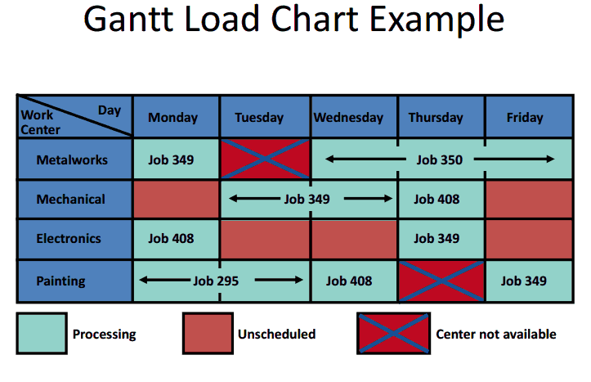Gantt Charts are used to show the “loading and idle times of departments, machines, or facilities; display relative workloads over time, and; monitor jobs in process” (Black, 2013). You can load jobs manually in a Gantt chart by the amount of capacity being your guide or by assigning specific jobs to work centers. Another assignment method that could be used is a linear programing model like the one we used to assign the machine operator staff to specific jobs with our set objective to minimize the total cost to complete the projects. Which ever method is used it is important to keep in mind that you are trying to minimize the completion time necessary, the work-in-process inventory & process cost, and the customer waiting time while maximizing the utilization of the facility.

Figure 1: Gantt Load Chat. (WGU, 2013)

References

Black, H. (2013). *BootCampVideos: JGT2 T1 - Short-term Scheduling*. Retrieved January 18, 2014, from wgu.hosted.Panopto.com : http://wgu.hosted.panopto.com/Panopto/Pages/Viewer/Default.aspx?id=38d0b717-7384-4b5b-9582-8ef722bfb958

WGU. (2013). *ShortTermScheduling.pdf.* Retrieved January 18, 2014, from Google Docs: https://docs.google.com/a/wgu.edu/file/d/0B35pwv5PkBKPSDlST2I 3TXVWQ1E/etdi